Call Joint R&D Project

Call for projects 2025-2026

CleanTech

Topics and rules

Deadline : 27 October 2025 at 2pm
Electronic submissions only to:
funding-request@innoviris.brussels and jduplicy@innoviris.brussels

More info ?

Jonathan Duplicy
jduplicy@innoviris.brussels
+32 2 600 50 52

Contexte et thématique JRIDC 2025-2026

The objective of the Joint R&D Project programme is to encourage collaboration between academia and the industrial sector in the Brussels-Capital Region. This programme requires active involvement from both academic units and industrial teams, with the aim of strengthening knowledge, transferring intellectual property from academic research to industry, and transforming it into solutions that create new opportunities. Companies will acquire the knowledge they lack or need, integrate the latest technology, and help adapt Brussels’ industry to the environmental and social transition, while academics will have access to real-life applications to implement their discoveries.
Following consultation with the ecosystem and in alignment with the Regional Innovation Plan (PRI)—in particular its strategic innovation areas of climate, optimal use of resources, efficient and sustainable urban flows, and advanced digital technologies—the theme of the 9th edition of the Joint R&D Projects call for proposals will be:

CleanTech

Cleantech encompasses a set of technological solutions and systemic approaches aimed at reducing the environmental footprint of human activities while fostering innovation and economic competitiveness. It includes solutions in the fields of renewable energy, energy efficiency, energy storage, natural resource management, recycling, and the circular economy.
Strengthening Cleantech has become a strategic imperative for Europe. In early 2025, the Competitiveness Compass laid out a roadmap to make Europe a hub for innovation and production of clean technologies, while achieving climate neutrality. The Draghi Report highlighted the importance of reindustrialising the continent around sustainable technologies, particularly to ensure energy and environmental sovereignty. In this context, the Clean Industrial Deal, which builds upon the Competitiveness Compass, aims to direct investment toward industry and infrastructure in order to accelerate growth and the industrial decarbonisation of the EU.
This plan strengthens decarbonisation goals by providing clear economic incentives for businesses. It aims to stimulate both the demand for and supply of clean technologies, while promoting sustainable industrialisation in Europe.
Brussels must fully embrace this momentum and seize new opportunities in this field by leveraging its industrial and academic strengths. Indeed, investing in Cleantech allows the Region to:
- Strengthen climate resilience and optimise energy management: through the development of smart buildings, the integration of renewable energy, and the optimisation of urban infrastructure for more efficient energy consumption.
- Accelerate the circular economy and resource valorisation: through innovations in advanced recycling, reuse of raw materials, and optimisation of waste flows to reduce pressure on natural resources.
- Modernise and decarbonise industry and transport: by adopting new low-carbon technologies, electrifying transport, and developing alternative fuels to reduce CO₂ emissions.
- Strengthen the strategic independence of Brussels and the EU: by developing local technological solutions, reducing reliance on fossil fuel imports, and fostering the emergence of new industrial value chains.
This theme is fully aligned with the strategic ambitions of the Brussels-Capital Region, which aims to support collaborative projects between universities, colleges, research centres, and innovative companies. The goal is to develop high-value Cleantech solutions that address environmental challenges while enhancing Brussels’ position as a reference hub for sustainable innovation and an active contributor to new European priorities.

Scope of the theme

As illustrated in the diagram below, within the framework of the Joint R&D Project “Cleantech” call, projects must focus on technological innovations that have the potential to:
- Significantly reduce or eliminate negative environmental impacts, or improve resilience to the effects of climate change;
- Improve the use of renewable resources or avoid the use of polluting resources;
- While delivering improved performance compared to conventional technologies, or reduced costs.
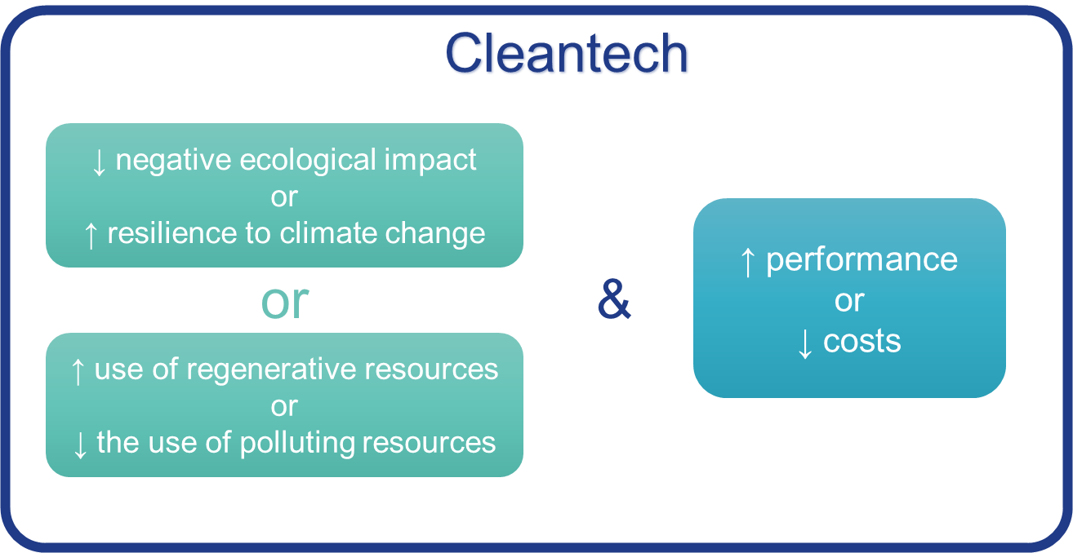

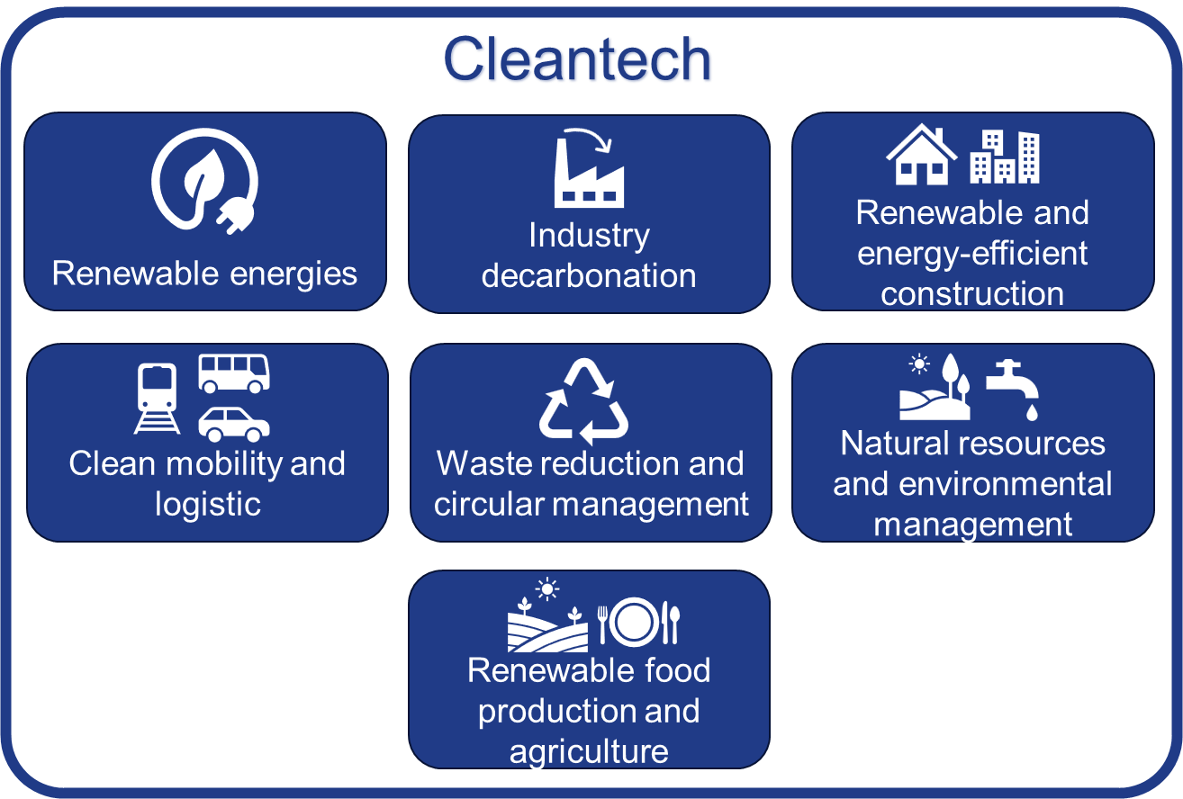
Thus, at least one of the application areas shown in the figure below must be addressed by project applicants.

For each application area, a few examples are listed below:

Renewable Energy
- Production and storage of electricity from renewable sources (solar, wind, biomass, green hydrogen, geothermal).
- Development of energy storage technologies (batteries, hydrogen, thermal storage solutions, etc.).
- Integration of smart grids to optimise energy distribution and consumption.

Sustainable Logistics and Clean Mobility
- Development of low-emission transport solutions.
- Optimisation of public transport and infrastructure for sustainable urban mobility.
- Green logistics and optimisation of goods flows to reduce the carbon footprint of transport.

Energy Efficiency and Sustainable Buildings
- Improving thermal performance of buildings and infrastructure (heating and cooling management).
- Use of sustainable materials and practices in construction and renovation.
- Deployment of intelligent energy management systems.

Environmental and Natural Resource Management
- Technologies for the capture, treatment, purification, and reuse of wastewater.
- Optimisation of drinking water networks and reduction of water use in industrial and domestic processes.
- Protection and restoration of natural environments (water, air, soil).

Waste Reduction and Circular Management
- Advanced recycling and waste valorisation.
- Development of bio-based and biodegradable materials.
- Reduction and management of electronic and plastic waste.

Industry Decarbonisation and Sustainable Production
- Carbon capture, utilisation, and storage (CCUS).
- Low-carbon manufacturing processes in energy-intensive industries.
- Use of advanced digital technologies to optimise production and minimise energy losses.

Sustainable Agriculture and Food
- Development of sustainable solutions and practices to optimise agricultural yields while reducing the use of chemical inputs.
- Development of plant-based substitutes or alternative proteins to reduce the carbon footprint of food.
- Integration of renewable energy in farming operations (biogas, solar panels).

Objectifs

The primary objective of the Joint R&D programme is to encourage cutting-edge academic developments that push back the boundaries of knowledge and technology, and to translate them into concrete applications through Brussels-based companies.
We therefore invite academic and industrial partners to submit collaborative project proposals aimed at addressing concrete challenges within the Cleantech application areas mentioned above.
Companies must propose—or aim to propose—a solution that targets one (or more) of these application cases and meets both the environmental and economic criteria that define Cleantech.
Working closely together, the academic partner(s) will carry out research on one or more of the components of the solution, while the company(ies) will work on integrating the university results.

Rules and scheduling of the call for projects

Programme’s objectives

The aim of the Joint R&D Project programme is to encourage collaboration between the academic and industrial sectors in the Brussels-Capital Region. This programme involves the active participation of both academic units and industrial teams with the aim of strengthening knowledge, transferring intellectual property from academic research to industry, and transforming it into solutions offering new opportunities. Companies will acquire the knowledge they lack or need, integrate the latest technology and adapt Brussels industry to the environmental and social transition, while academics will have real-life applications to implement their discoveries.
For this, in addition to being in line with the ‘CleanTech’ theme and the objectives defined above, it is expected that:
- The project involves at least one research organisation (university, higher education establishment or research centre) with at least one head office in the Brussels-Capital Region AND a company whose R&D activities are based in the Brussels-Capital Region;
- The project may thus involve the participation of more than one research organisation and more than one company. However, the balance of efforts (person-months) between academia and industry should respect a 1/3 – 2/3 balance; i.e. the sum of efforts of all partners from academia or industry should not be greater than 2/3 the total efforts of the project; effort is defined as “person-months”;
- The academic teams will have to carry out industrial research activities, while the companies are expected to put the results of the research into practice through experimental development work.

Amount of funding

The projects selected at the end of the 2 phases of the evaluation process will be financed in the form of grants, according to the rates below:

Micro- and Small Company | 60%
Medium Company | 50%
Large Company | 40%
Research Organisations | 100%

Eligible costs are as follows:
- Staff costs: costs relating to staff (salaried or self-employed) insofar as they are employed for the project. Salaries must comply with the practices and scales (where applicable) of the sector of activity concerned;
- Investment costs: costs of tools and equipment used during the project (purchase cost/depreciation period x duration of use in the project x usage rate);
- Sub-contracting costs: this mainly concerns sub-contracting in the broadest sense. The company may, if necessary and in a limited manner, call on relevant external expertise;
- Operating costs: in particular, the costs of materials, supplies and products required for the successful completion of the project.
A more detailed description of eligible costs is available in the Innoviris accounting guidelines.

Selection/evaluation of applications

The JRDIC "CleanTech" call for projects is divided into 2 phases:
- An initial expression of interest phase, enabling Innoviris to assess compliance with the eligibility conditions and the programme framework, as well as the project's relevance to the theme of the call for projects;
- A second phase, inviting the consortia selected during the expression of interest phase to submit a full project proposal, which will be evaluated by a jury made up of international experts and Innoviris.

Project Set-up Grant

Given that writing a complete and solid proposal is costly in terms of time and ressources and may constitute an obstacle to participation, Innoviris is offering a project set-up grant (named ‘Connect’) covering part of the related expenses to consortia selected at the end of the expression of interest phase (see ‘Selection and evaluation of applications’ below).
This grant amounts to a maximum of €7,500 per partner (with a ceiling of €25,000 per consortium). We encourage companies to devote part of this grant to studying the intellectual property aspects of the collaboration. Only consortia submitting a complete proposal will receive the grant. Interested partners should complete the application form attached to this document.
The funding is granted on the basis of European Commission Regulation 12023/2831 of 13 December 2023 on the application of Articles 107 and 108 of the Treaty on the Functioning of the European Union to de minimis aid.
This Regulation stipulates that the total amount of de minimis aid granted to any one beneficiary must not exceed €300,000 over any period of 3 years. It is the applicant’s responsibility to comply with this ceiling.

Intellectual property strategy

In an open innovation programme, it is fundamental that partners negotiate the intellectual property (IP) aspects of their project from the outset. Innoviris requires applicants to have agreed a high level IP strategy at the time of submission of expressions of interest. In addition, a signed consortium agreement must be submitted with the full proposal. The consortium agreement should define the framework for the successful implementation of the project. It is a private agreement between the partners, which defines mutual rights and obligations, and does not involve Innoviris. In particular, the agreement will define how an academic partner will be remunerated in the event of an effective transfer of intellectual property to an industrial partner.

Scheduling :

- 7 July 2025 : Launch of the call ;
- 27 October 2025 2pm : maximum delay for Innoviris to receive :
  - The expression of interest form (electronic submission only at funding-request@innoviris.brussels and jduplicy@innoviris.brussels)
  - Optional: the CONNECT form (attached to the above project outline forms);

- 21 November 2025 : Invitation to submit full proposals for consortia whose expression of interest has been retained. The selection of expressions of interest will be based on the eligibility requirements. However, if there is a high number of applications in regard to the budget available, Innoviris may go beyond the sole eligibility criteria and use the evaluation criteria (cf. above) to retain only the best eligible proposals;
- 6 February 2026, 2pm : The full project presentation form (electronic submission only at funding-request@innoviris.brussels and jduplicy@innoviris.brussels) :
- In March and April 2026: oral defense in front of a jury of experts and Innoviris – Innoviris evaluates the assessment aspects while the experts will assess the technical side of the project;
- On the basis of the evaluation, Innoviris will recommend to the Brussels government to fund the highest-ranked projects within the limits of the budget allocated to the call;
- From 1 March 2026 to December 2026: projects start.

Eligibility conditions:

- Propose a project that corresponds to the theme, objectives and scope of the call for projects ;
- The project must not have started before the application for support was submitted ;
- The application must be submitted no later than 2pm on 27/10/2025;

In addition, each partner must also meet the following conditions:
- Be a company or a research organisation: any company with a legal personality of any form (SA, ASBL, SC, SRL, etc.) or any research organisation meeting the definition in point 16 ff of the Framework for State Aid for Research and Development and Innovation 2022/C 414/01 (universities, higher education establishments, De Groote centres, etc.) on the closing date of the call;
- Not be in financial difficulty: see point 20 of the Guidelines on State aid for rescuing and restructuring firms in difficulty other than financial institutions. This aspect only concerns companies that have been in existence for more than three years;
- Not already benefiting from public support for the tasks included in the project (prohibition of double funding);
- Have at least one place of business in the BCR;
- Demonstrate the company's ability to finance its share of the project;
- Where applicable, have fulfilled its obligations to the Region in the context of previous aid.

Evaluation criteria

In addition to the contribution to the main objective of the call and the introduction of a collaboration agreement between the partners (see "Intellectual Property Strategy" above), projects will be assessed on the basis of the following 5 criteria:

- State of the art, Innovation and project objectives: The project objectives must be clear and concrete. In addition, the project must demonstrate the excellence of the research programme and contributions beyond the current state of knowledge for the research centre, as well as demonstrating the existence of technical challenges for the company ;
- Feasibility and implementation: the work programme must be relevant and realistic in terms of tasks, budget, expertise and resources ;
- Strategic and economic impact: the activity covered by the project must demonstrate real potential for creating value. The underlying assumptions must be set out in figures in a financial plan, demonstrating the economic sustainability of the activity studied. The project must be in line with the organisation's overall strategy and reflect a viable business model ;
- Societal impact: the activity covered by the project must demonstrate a social and/or environmental impact, as well as an impact on the Brussels ecosystem ;
- Relevance of the collaboration: the consortium must demonstrate the relevance of the collaboration to the project as a whole, and that the management of the collaboration is part of a concrete and effective strategy, particularly in terms of technology transfer from academia to industry and synergies between the partners.

Protection of personal data

The personal data collected by Innoviris, the data controller, by means of this form is for the purpose of processing your application for a grant (which involves, in particular, analysis and evaluation by Innoviris and an external jury). Processing is necessary for compliance with a legal obligation to which the data controller is subject (i.e. the non-economic ordinance and its implementing decree) and for the performance of a task in the public interest or in the exercise of official authority vested in the data controller. No data is shared with third parties without the prior consent of the data subject or unless Innoviris is required to do so by law. Innoviris makes every effort to guarantee the confidentiality and security of the data processed. The retention time will be that necessary to achieve the purposes of the processing concerned. If you have any questions or wish to apply your rights under Articles 15 to 22 of the GDPR, please contact dpo@innoviris.brussels or consult our "privacy" webpage.

Information et contacts

Further information can be obtained from Jonathan Duplicy, jduplicy@innoviris.brussels, 02/600.50.52.

Project presentation form
Deadline: 27 October 2025

[English is the preferred language but submissions in French and Dutch are welcome]

One-page overview

Explanatory note to be deleted
Please fit the content into one page

Project Title: …………………………………………………………………………
Project Keywords: …………………………………………………………………………
Project Duration: xx months
Project Partners: …………………………………………………………………………
…………………………………………………………………………
…………………………………………………………………………

Project Summary [NB. This summary might be used to anticipate the selection of experts. Please be as detailed as possible] :
………………………………………………………………………………………………………………………………………………………………..
………………………………………………………………………………………………………………………………………………………………..
………………………………………………………………………………………………………………………………………………………………..
………………………………………………………………………………………………………………………………………………………………..
………………………………………………………………………………………………………………………………………………………………..
………………………………………………………………………………………………………………………………………………………………..
………………………………………………………………………………………………………………………………………………………………..
………………………………………………………………………………………………………………………………………………………………..
………………………………………………………………………………………………………………………………………………………………..
………………………………………………………………………………………………………………………………………………………………..
………………………………………………………………………………………………………………………………………………………………..
………………………………………………………………………………………………………………………………………………………………..
………………………………………………………………………………………………………………………………………………………………..
………………………………………………………………………………………………………………………………………………………………..
………………………………………………………………………………………………………………………………………………………………..

Consortium presentation

Explanatory note to be deleted
- Please copy/paste the relevant tables if the consortium is made up of more than two partners. Each table should fit in one page.

Research Organisation(s)

Research organisation | Name: ………………………….
Research unit | Name: …………………………  Research activities: …………………………………………………………………………..  …………………………………………………………………………………………………………..  …………………………………………………………………………………………………………..
Persons in charge | Person legally authorised to bind the organisation:  Name: ………………………… Position: …………………………  Administrative manager for the project:  Name: ………………………… Position: …………………………  E-mail: ………………………… Telephone number: …………………………  Technical and scientific manager for the project:  Name: ………………………… Position: …………………………  E-mail: ………………………… Telephone number: …………………………
Role in the project | Describe the role of the Partner in the project and the specific skills he will bring to the project

Company(ies)

Company | Name: …………………………..  Company No. ………………………….  Bank account No. …………………………. [Please append a bank identification document ]  Sector: …………………………  Size: micro-small-medium-large company  Please provide the company’s 2024 accounts in an annex.
Company Division | Name: …………………………  R&D activities: …………………………………………………………………………..  …………………………………………………………………………………………………………..  …………………………………………………………………………………………………………..  …………………………………………………………………………………………………………..
Persons in charge | Person legally authorised to bind the organisation:  Name: ………………………… Position: …………………………  Administrative manager for the project:  Name: ………………………… Position: …………………………  E-mail: ………………………… Telephone number: …………………………  Technical and scientific manager for the project:  Name: ………………………… Position: …………………………  E-mail: ………………………… Telephone number: …………………………
Role in the project | Describe the role of the Partner in the project and the specific skills he will bring to the project

Presentation of the project

Goals
2 pages:
………………………………………………………………………………………………………………………………………………………………..
………………………………………………………………………………………………………………………………………………………………..
………………………………………………………………………………………………………………………………………………………………..
………………………………………………………………………………………………………………………………………………………………..
………………………………………………………………………………………………………………………………………………………………..
………………………………………………………………………………………………………………………………………………………………..
………………………………………………………………………………………………………………………………………………………………..
………………………………………………………………………………………………………………………………………………………………..
………………………………………………………………………………………………………………………………………………………………..
………………………………………………………………………………………………………………………………………………………………..
………………………………………………………………………………………………………………………………………………………………..
………………………………………………………………………………………………………………………………………………………………..
………………………………………………………………………………………………………………………………………………………………..
………………………………………………………………………………………………………………………………………………………………..
………………………………………………………………………………………………………………………………………………………………..

Innovative nature
1 page: Explain how the project is innovative both from an industrial and an academic point of view
………………………………………………………………………………………………………………………………………………………………..
………………………………………………………………………………………………………………………………………………………………..
………………………………………………………………………………………………………………………………………………………………..
………………………………………………………………………………………………………………………………………………………………..
………………………………………………………………………………………………………………………………………………………………..
………………………………………………………………………………………………………………………………………………………………..
………………………………………………………………………………………………………………………………………………………………..
………………………………………………………………………………………………………………………………………………………………..
………………………………………………………………………………………………………………………………………………………………..
………………………………………………………………………………………………………………………………………………………………..
………………………………………………………………………………………………………………………………………………………………..
………………………………………………………………………………………………………………………………………………………………..
………………………………………………………………………………………………………………………………………………………………..
………………………………………………………………………………………………………………………………………………………………..
………………………………………………………………………………………………………………………………………………………………..

Match with the call topic
Half a page: Explain how the project matches with the call topic (CleanTech)
………………………………………………………………………………………………………………………………………………………………..
………………………………………………………………………………………………………………………………………………………………..
………………………………………………………………………………………………………………………………………………………………..
………………………………………………………………………………………………………………………………………………………………..
………………………………………………………………………………………………………………………………………………………………..

Assessment of the project outcomes
1 page: Explain how results will be assessed both from a business and an academic point of view (jobs, expertise, growth, publications, spin-offs, etc.) and the impact the project will have on the Brussels Region from a social, environmental and ecosystem perspective.
………………………………………………………………………………………………………………………………………………………………..
………………………………………………………………………………………………………………………………………………………………..
………………………………………………………………………………………………………………………………………………………………..
………………………………………………………………………………………………………………………………………………………………..
………………………………………………………………………………………………………………………………………………………………..
………………………………………………………………………………………………………………………………………………………………..
………………………………………………………………………………………………………………………………………………………………..
………………………………………………………………………………………………………………………………………………………………..
………………………………………………………………………………………………………………………………………………………………..
………………………………………………………………………………………………………………………………………………………………..
………………………………………………………………………………………………………………………………………………………………..
………………………………………………………………………………………………………………………………………………………………..

Budget estimate
-Total Budget estimate: xx €
-Total Subsidy estimate: xx €

Explanatory note to be deleted
- Please copy/paste the table below and rename the title to cover the whole consortium.
- The budget is not definitive at this stage and will be readjusted at the Full Project Proposal stage.

Partner X
Estimated effort (persons/month) | X MM
Provisional budget | 0 €
Funding rate | X %
Subsidy | 0 €

Signatures

Explanatory note to be deleted
- Please copy/paste the table below and rename the title to cover the whole consortium.

Partner X
By signing the document, I certify that (please tick the boxes):
☐ | I have read and agree to the programme guidelines;
☐  ☐ | All the information provided in this document is correct;  I am attaching the 2024 accounts (for industrial partners);
☐ | The IP aspects of the project have been discussed with the other partners and an IP strategy has been agreed upon;
☐ | I am aware that a signed consortium agreement will be requested at the same time as the submission of the full proposal (if the expression of interest is retained).

Name (legal representative): …………………………..
Position: ……………………….
Signature and date:

CONNECT 2025

Request for Subsidy

One form per participant

Name of the applicant

"Project title"

Type of Partner
☐ Academia
☐ Company
Budget | €XXXX
Funding rate | %
Subsidy requested (max € 7,500) | €
Period | 21 November 2025 to 6 February 2026

General context:
In order to encourage the teaming up of academic partners with companies to set up interesting R&D projects in the field of health, Innoviris provides the possibility of covering parts of the costs associated with preparation. A maximum amount of € 7,500 can be granted to each partner in the consortium (with a total cap of € 25,000 per consortium) in order to cover the personnel costs of the person(s) in charge of discussing, negotiating and writing the proposals, and also, if needed, legal advice on intellectual property issues.

Process:
- The application form for set-up support should be submitted to INNOVIRIS together with the expression of interest form before October 27 2025 at 2pm;
- If your expression of interest is selected and the consortium is invited to send in a full project proposal, your CONNECT subsidy will be accepted upon submission of the latter. Should no full proposal be submitted, the partners will not be eligible for the CONNECT subsidy, and the costs incurred will not be covered; your CONNECT application will also be automatically rejected if your expression of interest is not selected.
- Each partner of the consortium can submit a CONNECT form, and the consortium shall ensure that the maximum amount does not exceed the limit;
- The CONNECT subsidy covers the period between the submission of the expression of interest and the full proposal;
- Expenditure can be covered up to the date on which the final project proposal is submitted to Innoviris;
- Cost statements must be submitted within two months of the submission of the full proposal;
- For companies only: as this subsidy is considered as de minimis aid, a sworn statement should be attached to the CONNECT form (see Annex 1).

.

Detailed description of the preparatory work and necessary actions for setting up the project

Informative note to be deleted
Please describe in detail all actions that will be undertaken for setting up the full proposal, and for which you are requesting funding from the Region (drafting of full proposal, meetings, etc.).

…………………………………………………………………………………………………………………………………………………………………………………………………………………………………………………………………………………………………………………………………………………………… (max. 2 pages)

Budget for setting up the project

Explanatory note to be deleted
Copy and paste the table below

Draw up the budget for the project preparation for the relevant period (including sub-contractors), using the template provided

If your organisation is liable for VAT, the expenses to be taken into consideration should not include VAT.
Admissible costs cover:
- staff costs incurred in the context of setting up the project,
- legal advice on IP subcontracted.
Only expenses incurred after Innoviris has made a positive decision on the expression of interest and after submission of the full proposal will be covered.
Staff costs:
These include expenses relating to the remuneration of the team in charge of setting up the project (local coordinators, researchers, etc.). Applicants should distinguish between employees (1.1) and self-employed workers (1.2). The average person/month cost shall be considered as an average of the unit cost for the different members of the team (local coordinators, researchers, etc.) of the specific partner.
Each amount should be calculated on the basis of an average of costs, meaning that salary slips or invoices should be submitted at the stage when expenses are verified.

Overheads:
This is a fixed amount to cover additional costs incurred as a result of the setting-up of the project (secretariat, bookkeeping, telecommunications, inspections, travel in Belgium, etc.). The fixed amount is set at 10% of the amount for salaried staff costs (1.1).

Subcontracting costs:
These costs cover the expenses linked with legal consulting services in order to solve IP questions during the preparation of the project.

Financing rate:
- 70% for companies
- 100% for research organisations

1. | Staff costs |  |  |  | €
1.1 | Employees/salaried staff |  |  |  | €
 | Number of person/months for the preparation of the project |  |  | Average person-month cost | Total
 |  |  |  |  | €
1.2 | Self-employed staff |  |  |  | €
 | Number of person/months for the preparation of the project |  |  | Average person-month cost | Total
 |  |  |  |  | €

2. | Overheads | €
 | 10% of salaried staff costs

3. | Subcontractors | €
 | Legal IP services | €

TOTAL  INTERVENTION RATE | €  %
SUBSIDY REQUESTED | €

Authorisation and signature

By signing the document, I certify that (please tick the boxes):
☐ | I have read and agree to the programme guidelines;
☐ | All the information provided in this document is true and accurate;
☐ | I authorise Innoviris to proceed with the necessary investigation for the examination of this application.

Signature by the legal representative:
Name: …………………………..
Position: ……………………….
Signature & date:

Annex 1- Declaration of Honour (only to be filled in by companies)

Sworn Statement

I, Mrs/Ms/Mr …..., in my capacity as administrator, manager, director of the company:
Name of Company: ….
Address: …
Company Number: …
Having submitted an application for funding for the project entitled "..... " in the framework of Joint R&D Project 2025 – CleanTech
Subsidy requested: ……. €

This intervention of the Brussels-Capital Region is granted to me by reference to European Commission Regulation 2023/2831, dated 13 December 2023, concerning the application of Articles 107 and 108 of the Treaty on the Functioning of the European Union for de minimis aid.

I hereby acknowledge that the amount of the subsidy mentioned above does not bring the total amount of aid already granted to me under said Regulation to an amount exceeding € 300,000 over a period of 3 fiscal years.

This limit shall apply regardless of the form of the aid or the nature of the subsidising entity. The amount of aid granted in this case must therefore be taken into account if I receive further de minimis aid at a later stage.

I hereby declare on my honour that the present statement is truthful and complete

Date: Signature

As defined in the ordonnance of July 27th 2017 designed to promote research, development and innovation by granting aid for economic purposes to businesses and research bodies treated as businesses, and in particular Articles 13 and 14 thereof.
Pursuant to the Ordonnance of 27 July 2017 aimed at promoting research, development and innovation by granting aid earmarked for economic purposes in favour of businesses and research bodies treated as businesses, and more particularly Articles 13 and 14 thereof.
This is the average cost for the various types of profiles working on the preparation of the full proposal

